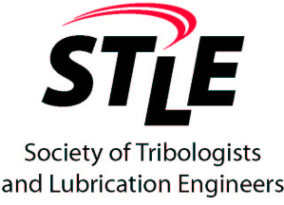

Subject: STLE 2020 - 21 Scholarship Announcement

For: Scholarships of up to $1500.00 for Graduate Students

The Detroit Section of STLE (Society of Tribologists and Lubrication Engineers) is announcing our 2020 - 21 Scholarship Program. The STLE Detroit Section has allocated a fund of $2500 to be awarded as scholarships for the 2020 - 21 academic year. We intend to award two scholarships: one for $1500 and one for $1000.

The STLE Detroit Section Scholarship Program is based upon three items:

- copy of transcript.
- letter of recommendation from a faculty member.
- a written essay to describe “how does tribology and/or lubrication relate to your research or future career goal?”

All information is due on March 1, 2020. The Detroit STLE Scholarship Committee will evaluate all submissions during March, and winners will be notified in late March. In addition, winners and their academic advisors will be invited to make a short presentation about their research programs during our Spring 2020 Speakers Meeting on Wednesday, April 22, 2020 in Southfield, MI. (Location will be the Eaton Innovation Center, 26101 Northwestern Highway, Southfield, MI 48076.) Winners and Advisors will be guests of the section.

The STLE Detroit Section has a long history of supporting education thru scholarship. We look forward to encouraging and rewarding the future tribologists and lubrication engineers in the area. Attached please find the STLE Detroit Section Scholarship Application Form. For more background on STLE, please visit www.stle.org. Please let me or Zhe know if you have any questions.

Mr. Bill Kearney | Mr. Zhe Li
Afton Chemical | General Motors Corp.
21927 Greentree Lane | 800 N Glenwood Ave
Novi, MI 48375 | Pontiac, MI, 48340
E-mail: bill.kearney@aftonchemical.com or  Bill.kearney456@gmail.com | E-mail: Zhe.Li@gm.com
Tel: (248) 380-7596 | Tel: (248) 568-2852

Attachment: STLE Detroit Section Scholarship Application Form

