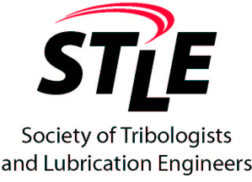

2020 - 21 Scholarship Application Form

Society of Tribologists and Lubrication Engineers

Detroit Section

Name: _______________________________________________________________

Address: _____________________________________________________________

Phone: ____________________ E-Mail: ___________________________________

School: __________________________ Department: ________________________

Research Advisor: _____________________________________________________

Academic Major: ______________________________________________________

All Applicants Must Submit The Following Three Items:

- Copy of Transcript (Official Copies Are Desirable but Not Mandatory)

- Letter of Recommendation from a Faculty Member

- A written essay (1000 words or less) to describe “How does tribology and/or lubrication relate to your research or future career goal?”

A research paper (or review paper) in the tribology or lubrication area will be welcome and may help your application, but is not mandatory.

Please send this form along with the above requirements before March 1, 2020, to either:

Mr. Bill Kearney | Mr. Zhe Li
Afton Chemical | General Motors Corp.
21927 Greentree Lane | 800 N Glenwood Ave
Novi, MI 48375 | Pontiac, MI, 48340
E-mail: bill.kearney@aftonchemical.com or  Bill.kearney456@gmail.com | E-mail: Zhe.Li@gm.com
Tel: (248) 380-7596 | Tel: (248) 568-2852

